**RESTEasy Framework:**

**Project Structure:**

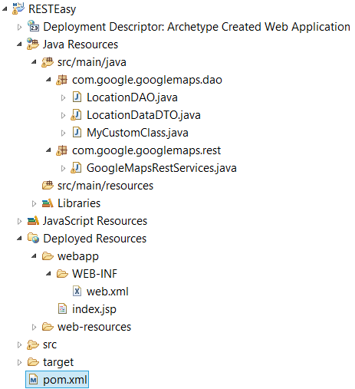

**Note: All the codes in the program will remain the same, We only have to add the dependencies of RESTEasy and we have to configure the Web.xml to use RESTEasy Framework.**

**Configuring the pom.xml:**

<project…>

<repositories>

<repository>

<id>JBoss repository</id>

<url>

<https://repository.jboss.org/nexus/content/groups/public-jboss/>

</url>

</repository>

</repositories>

<dependencies>

<dependency>

<groupId>javax.servlet</groupId>

<artifactId>servlet-api</artifactId>

<version>2.5</version>

</dependency>

<dependency>

<groupId>org.jboss.resteasy</groupId>

<artifactId>resteasy-jaxrs</artifactId>

<version>2.2.1.GA</version>

</dependency>

</dependencies>

<build>

<finalName>RESTEasy</finalName>

</build>

</project>

**Configuring the Web.xml:**

<!DOCTYPE web-app PUBLIC

"-//Sun Microsystems, Inc.//DTD Web Application 2.3//EN"

"http://java.sun.com/dtd/web-app_2_3.dtd" >

<web-app>

<display-name>

Archetype Created Web Application

</display-name>

<!-- Auto scan REST service -->

<context-param>

<param-name>resteasy.scan</param-name>

<param-value>true</param-value>

</context-param>

<!-- this need same with resteasy servlet url-pattern -->

<context-param>

<param-name>

resteasy.servlet.mapping.prefix

</param-name>

<param-value>/rest</param-value>

</context-param>

<listener>

<listener-class>

org.jboss.resteasy.plugins.server.servlet.ResteasyBootstrap

</listener-class>

</listener>

<servlet>

<servlet-name>resteasy-servlet</servlet-name>

<servlet-class>

org.jboss.resteasy.plugins.server.servlet.HttpServletDispatcher

</servlet-class>

</servlet>

<servlet-mapping>

<servlet-name>resteasy-servlet</servlet-name>

<url-pattern>/rest/*</url-pattern>

</servlet-mapping>

</web-app>

**Note**  
You need to set the “**resteasy.servlet.mapping.prefix**” if your servlet-mapping for the resteasy servlet has a url-pattern other than “**/\***“.

In above example, the resteasy servlet url-pattern is “**/rest/\***“, so you have to set the “resteasy.servlet.mapping.prefix” to “**/rest**” as well, otherwise, you will hit resource not found error message.

**Note**  
Remember to set “**resteasy.scan**” to true, so that RESTEasy will find and register your REST service automatically.